Project Design Phase-II
Data Flow Diagram & User Stories

Date | 31 January 2025
Team ID | [Enter Team ID]
Project Name | AI-Powered Debt Relief & Financial Recovery Platform
Maximum Marks | 4 Marks

Data Flow Diagrams:
A Data Flow Diagram (DFD) is a traditional visual representation of the information flows within a system. A neat and clear DFD can depict the right amount of the system requirement graphically. It shows how data enters and leaves the system, what changes the information, and where data is stored.
Example: DFD Level 0 (Industry Standard)
Project Data Flow Diagram (Level 0 & Level 1):
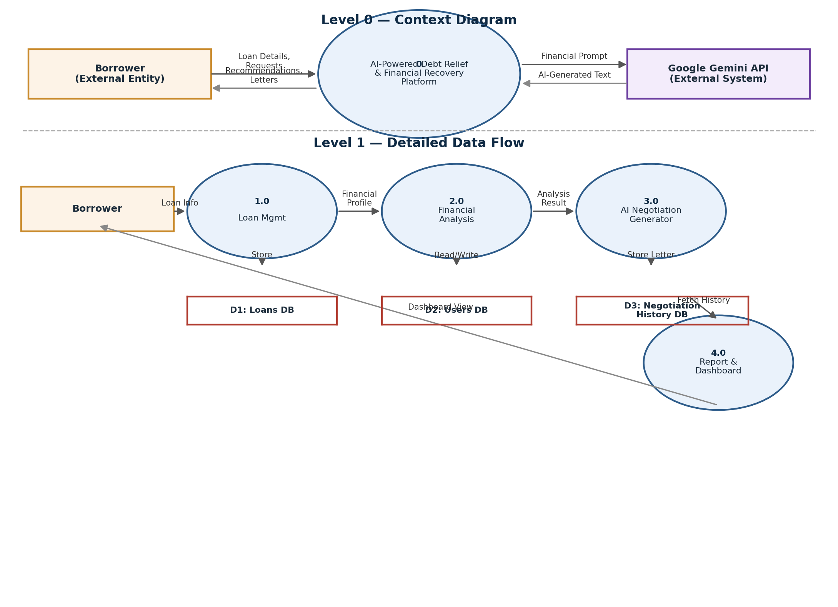
Example: (Simplified)
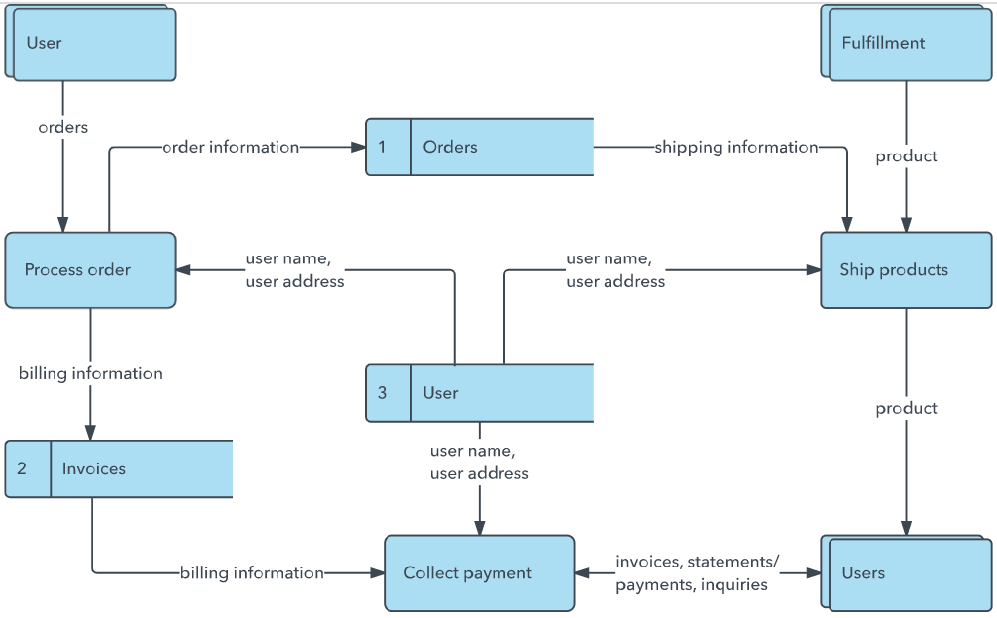


User Stories
Use the below template to list all the user stories for the product.
User Type | Functional Requirement (Epic) | User Story Number | User Story / Task | Acceptance criteria | Priority | Release
Borrower | User Registration | USN-1 | As a borrower, I can register for the application by entering my email, password, and confirming my password. | I can access my account/dashboard after registration | High | Sprint-1
 |  | USN-2 | As a borrower, I can log in using my registered email and password. | I can access my dashboard after successful login | High | Sprint-1
 | Loan Management | USN-3 | As a borrower, I can add a new loan with outstanding amount, EMI, overdue duration, and monthly income. | The loan appears in my dashboard immediately after saving | High | Sprint-1
 |  | USN-4 | As a borrower, I can edit or delete an existing loan record. | Changes are reflected instantly in the dashboard | Medium | Sprint-1
 | Financial Health Analysis | USN-5 | As a borrower, I can view my EMI ratio, monthly surplus, and debt stress level for each loan. | Metrics update automatically when loan details change | High | Sprint-2
 | AI Settlement Recommendation | USN-6 | As a borrower, I can request a personalized settlement recommendation based on my financial profile. | I receive a settlement percentage with a clear rationale | High | Sprint-2
 | AI Negotiation Letter Generation | USN-7 | As a borrower, I can generate a lender-specific negotiation email using AI. | A professional, editable negotiation letter is generated within seconds | High | Sprint-3
 | Negotiation History | USN-8 | As a borrower, I can view a history of all previously generated negotiation letters. | Past letters are listed with date and associated loan account | Medium | Sprint-3
Administrator | Monitoring | USN-9 | As an administrator, I can monitor overall platform usage and flagged negotiation requests. | Admin dashboard reflects real-time usage statistics | Low | Sprint-3

